1.Write a C++ program to find the size of int, float, double and char in your system.
#include<iostream>
using namespace std;
int main()
{
cout<<"Size of char: "<<sizeof(char)<<" bytes"<<"\n";
cout<<"Size of int: "<<sizeof(int)<<" bytes"<<"\n";
cout<<"Size of float: "<<sizeof(float)<<" bytes"<<"\n";
cout<<"Size of double: "<<sizeof(double)<<" bytes"<<"\n";
return 0;
}
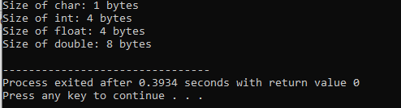

2.Write a C++ program to find the product of two numbers entered by the user.
#include<iostream>
using namespace std;
int main()
{
float a,b,c;
cout<<"Enter two numbers: ";
cin>>a>>b;
c=a*b;
cout<<"Product="<<c;

}
